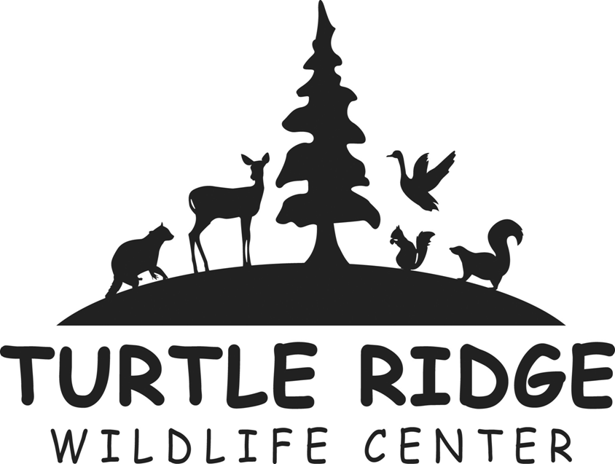
“Fostering and Caring for Wildlife”
PO Box 768
Salem, OR 97308
503-540-8664

TRWC Animal Care Internship Application

Date

Name

Address

City State Zip

Home Phone Work Phone

Cell Phone E-Mail

Occupation Employer

Which is the best number to call during the daytime? Home Work Cell

Do you meet our minimum age requirement of 21 years? Yes No

Available Start Date
Required Finish Date

You are required to have your own vehicle. You may also be asked to perform physical labor, including standing, walking, lifting up to 50 pounds, and outdoor work during all types of weather. Are you willing and physically able to perform these types of duties? Yes No

Do you have any animal or outdoor allergies? Yes No

If yes, please list

How did you find out about the Turtle Ridge Wildlife Center Internship Program?

Please list two professional and/or academic references:

Reference #1 Name
Daytime Phone
E-Mail
Relationship

Reference #2 Name
Daytime Phone
E-Mail
Relationship

Please mail application and a resume to Attn: Jessy Gill, Turtle Ridge Wildlife Center, PO Box 768, Salem, OR 97308. In lieu of a resume you may attach a page listing details of work, school, or volunteer activities. Incomplete materials will not be considered. If you have questions, please contact Jessy Gill at 503-362-8924.

If accepted for this internship, I agree to abide by the policies and procedures of Turtle Ridge Wildlife Center and to perform the duties of this position with a strong work ethic and high level of personal integrity. I agree to respect the philosophies of the organization, and I will provide the best possible care for the animals placed in my hands.

By signing this application, I indicate that I am aware that the internship I am applying for is voluntary and that housing and a stipend of $50 per week (up to $550) are available.

_______________________________________ ____________________________________
Signature Date

Revised 01/22/2018

