DEER
Deer are beautiful animals that are not a threat to other wildlife. They can blend into the surroundings or run with great agility when needed. Their true beauty lies in their simple, yet graceful presence. Watching them is wonderful but it is critical that we maintain a distance and keep them wild. They naturally fear people but will lose their natural ways if they become too comfortable in the presence of humans and that’s when conflict occurs.

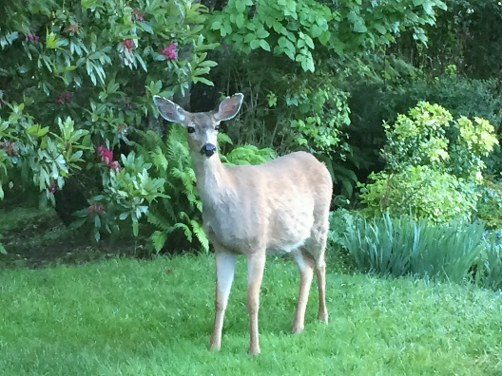
Deer in the wild eat a wide variety of plants, fruit, nuts, acorns, fungi, and lichens. In late winter and early spring, they will eat grass, clover, and other herbaceous plants. But their main food is browse—the growing tips of trees and shrubs. The plants they most prefer, and that frequently suffer damage, include firs, fruit trees, hostas, ivy, junipers, some pines, tulips, roses, day lilies, and yews.
Courtesy V. Stiteler

Deer normally breed in November and December and pregnancy lasts 180 to 200 days. A younger doe will give birth to one fawn, while an older doe that is in good condition often has twins and occasionally triplets.

With good intentions, people try to help deer by feeding them. This can lead to health issues if the food is not a part of their diet, encourages them to lose their natural wariness of humans, and can attract predators, like cougars, that follow deer herds
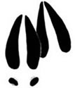
From Animal Tracks of the Pacific Northwest
Tracks. Deer tracks are easy to identify and are 1½ to 3¼ inches long.
Two hoofed toes form a heart-shaped track. The toes are pointed, and two dewclaws may show in soft surfaces or when they are moving fast.

Tips for avoiding conflict:
- Do not feed deer or provide them with salt or mineral licks.
- Never approach deer; if threatened, deer can cause serious injury and females are extremely protective of their young.
- Keep pets inside when deer are in the yard.
- Eliminate unwanted browsing of landscaping plants and gardens by enclosing the area with a fence that is at least 7-8 feet high.
- Use native rather than ornamental shrubs and plants that can withstand occasional browsing by deer.
- Landscape with deer-resistant plants (lists are available at the Oregon Department of Fish and Wildlife office and at some garden supply stores).
- Cover window wells to prevent them from getting trapped or injured.
- Vehicles kill hundreds of deer each year; drive slowly through deer habitats, especially at dawn and dusk.
- Pick up fallen tree fruit.
- Install tree guards or chicken wire to protect tree bark from deer antlers.
- Install motion-sensitive lighting around the house and garden.
- Consider using commercially prepared deer repellents.
- If you see a deer fawn on its own, the best thing to do is to keep your distance and leave the animal where you found it; the mother is usually close by.

Involving your neighbors in efforts to eliminate attractants is often the best way to avoid conflicts. Please help keep deer wild and appreciated.

