RACCOONS
Despite their mischievous ways, raccoons play an important role in keeping ecosystems clean and healthy. Their diverse diet can keep your yard free of pests, such as wasp larvae, insects, slugs, and small rodents. As scavengers, they will also clean up carrion and feed on unwanted vegetation and weeds. They feast on berries and nuts, which in turn helps plants spread seeds.

Raccoons are nocturnal so will mainly be active at night. While mostly solitary, the mother will be out with her young while she teaches them the skills needed for survival. They typically breed from January to March and three to five young are born in April or May. The young will go off on their own later in the fall.
From Animal Tracks of the Pacific Northwest
Tracks. They can be seen in soft soil, sand, mud, or surfaces that raccoons use to gain access to structures, such as deck railings or downspouts. Their long, sharp, and nonretractable claws make them good climbers. By rotating their hind feet 180 degrees, they can descend trees headfirst.
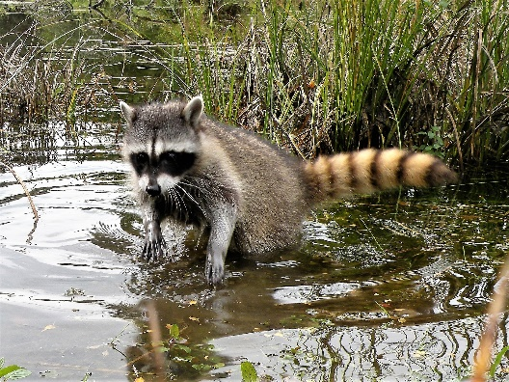
Human/raccoon conflicts can occur when they find shelter or food in an urban setting. They can enter through an existing opening in a structure or they can dig and rip an opening. If the opportunity exists, they may nest in attics, chimneys, basements and garages. If raccoons are kept out of human homes, not cornered, and not treated as pets, they are not dangerous.

Tips for avoiding conflict:
- Do not approach or try to feed raccoons.
- Do not leave human or pet food in the yard.
- Keep pets indoors at night and keep vaccinations current.
- Install chimney caps and close all openings to prevent them from nesting (do this in the fall when they are not raising young).
- Install motion sensor lighting to discourage visits.
- Trim overhanging tree limbs away from your roof.
- Cover window wells with a grate so they don’t fall in and get trapped.
- Lock pet doors to keep them from entering your home in search of food.
- Fence off gardens or ponds.
- Secure a raccoon guard around trees, pipes, posts, and other structures to keep them from climbing.
- Regularly pick up fallen birdseed and fruit.
- Use tree guards to protect nest boxes.
- Clean barbecue grills thoroughly after each use.
- Secure trash and compost with tight fitting lids.

Involving your neighbors in efforts to eliminate attractants is often the best way to avoid conflicts. Please help keep raccoons wild and appreciated.

